***Mobile Programming practical***

*Practical no.1*

**Aim :** Write program to demonstrate the features of dart languages.

1. Write a program in dart to print “Hello World!” using for loop.

**Code :**

void main() {

for(int i=0; i<5; i++){

print(‘Hello World ${i+1}’);

}

}

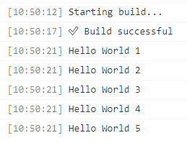

1. Write a program to print greater number using conditional statement.

**Code :**

void main() {

  var a=30;

  var b = 20;

  if (a>b) {

    print('a is greater than b.');

  }

  else{

    print('b is greater than a.');

  }

}

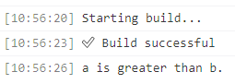

1. Write a program to check the enter number is odd or even.

**Code :**

void main() {

  var a=20;

  print("Checking Odd Even:");

  if(a%2==0){

    print("The given number is even.");

  }

  else{

    print("The given number is even.");

}

}

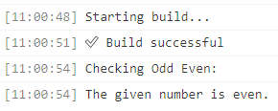

1. Write a program 1 to 10 using for loop.

**Code :**

void main() {

  int num =1;

for(num; num<=10; num++){

    print(num);

  }

}

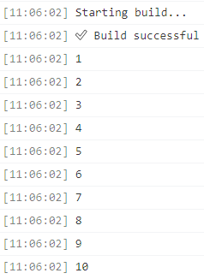

1. Write a dart program to print list content using for in loop.

**Code :**

void main() {

  var list = [10, 20, 30, 40];

  for (var i in list){

    print(i);

  }

}

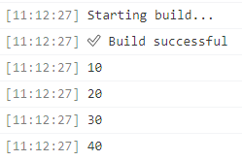

1. Write a program to print a sum of 2 numbers using function.

**Code :**

void main() {

  int sum(int a, int b){

    int result;

    result = a + b;

    return result;

  }

  var c = sum(10, 20);

  print("the sum of number is : $c");

}

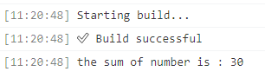

1. Write a program to print factorial of the number.

**Code :**

int factorial(int num){

  if(num<=1){

    return 1;

  }

  else {

    return num * factorial(num-1);

  }

}

void main() {

  int number = 5;

  int fact = factorial(number);

  print("Factorial for 5 is : $fact");

}

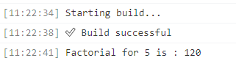

1. Write a program to create a class and display the object information.

**Code :**